THE SOOTY SHOW LIVE UK TOUR
FRIDAY 7TH FEBRUARY 2014 – SUNDAY 29TH JUNE 2014
PLEASE SEE LISTINGS BELOW, MORE DATES TO BE ADDED
www.thesootyshow.com

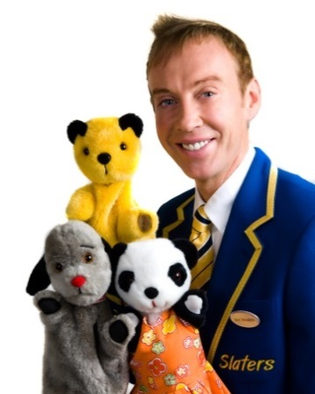
Sooty & Friends
Recently celebrating his 65th year in show business Sooty, the nation’s favourite bear, will be embarking on a UK tour in 2014. Here is a look back at some famous friends Sooty has made during his exciting TV career.

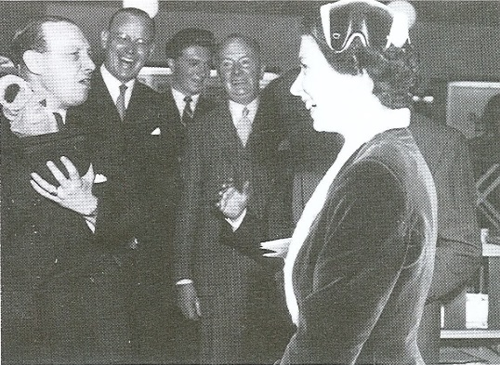  The Queen met Sooty in 1955 when he mischievously squirted water in Prince Phillips face! Her Majesty also said Sooty was Princess Anne’s favourite programme, let’s hope Prince George is a fan of The Sooty Show too! | 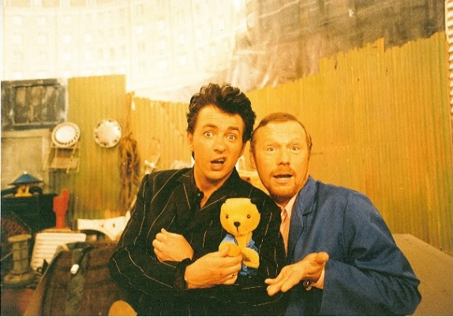  Shane Ritchie has been friends with Sooty for years as he starred in the 1997 Sooty’s Christmas Panto.
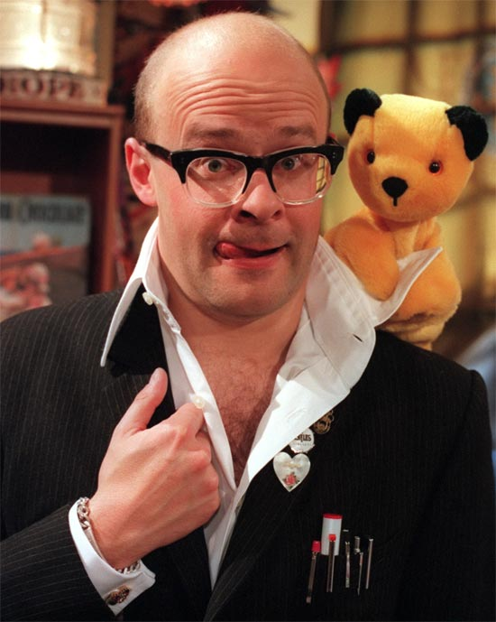  Harry Hill and Sooty go way back since Harry starred in Sooty & Co in 1998. | 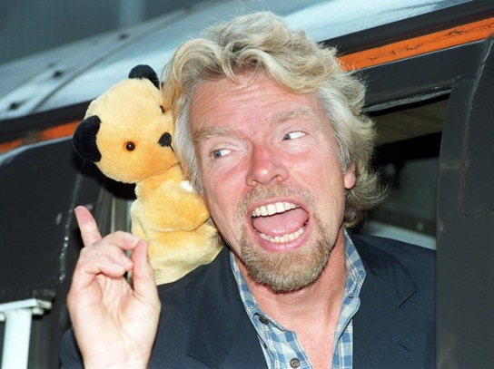  Sooty talks business with Richard Branson in 1998 – or show business!
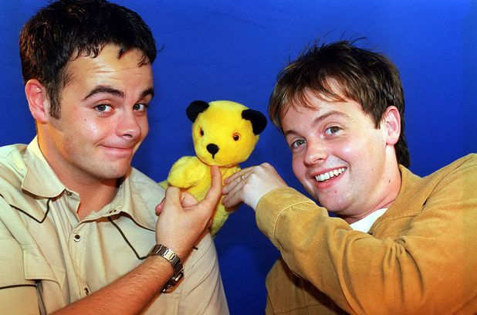  Back in 2000 when Ant and Dec think Sooty’s Got Talent! | 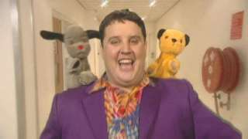  Sooty and Sweep helped Peter Kay find the way to Amarillo for his 2005 Comic Relief single.
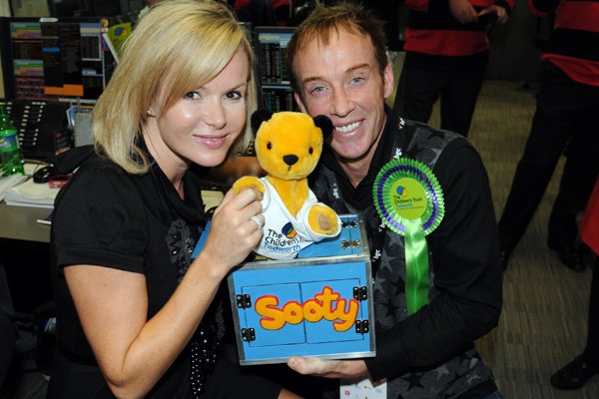  Sooty had the pleasure of working with Amanda Holden in 2010 for The Children’s Trust. | 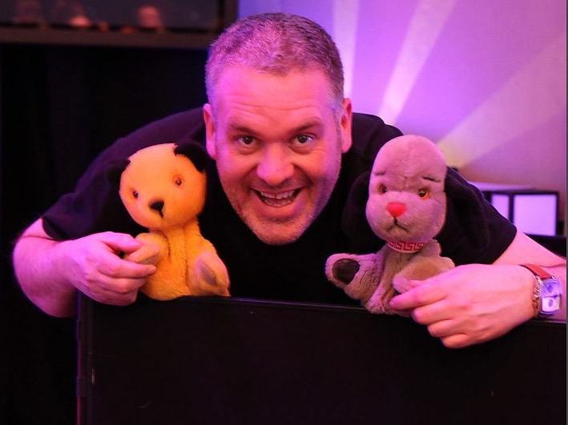  Sooty and Sweep surprised Chris Moyles for his 2011 radio birthday show.
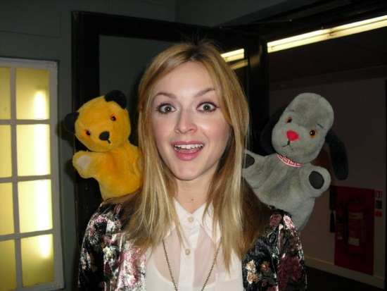  Sooty and Sweep hanging out with Fearne Cotton at BBC Radio 1 in 2011. | Amy Childs brought Essex to Somerset for filming the new series of The Sooty Show 2013.

NOTES TO EDITORS
The Sooty show is the longest running children’s programme in the world. This year, it has been on our television screens for 65 years. Harry Corbett originally bought Sooty for his son Matthew Corbett whilst on holiday in Blackpool in 1948. Sooty first appeared on our screens in 1952. Following Harry Corbett's retirement in 1976, Sooty was operated by Corbett's son Matthew, and enjoyed a new wave of popularity on stage and TV.
Matthew Corbett retired in 1998, giving Sooty to then co-star Richard Cadell who presented the show through another five series. In June 2008, Richard Cadell bought the rights to Sooty.
CONTINUE FOR LISTINGS

Date | Town | Venue | Box Office
JULY 2014
Saturday 5th | Tenbury Wells | Ludlow Arts Festival |  | 08442 485 165
Sunday 6th | Tunbridge Wells | Assembly Halls |  | 01892 530613
Saturday 12th | Gravesend | Woodville Halls |  | 01474 337774
Sunday 13th | Skegness | Embassy Theatre |  | 0845 674 0505
Saturday 19th | Tamworth | Tamworth Assembly Rooms |  | 01827 709618
Sunday 20th | Horsham | The Capitol |  | 01403 750 220
Thursday 24th | Bedford | Corn Exchange |  | 01234 344 813
Fri & Sat, 25th & 26th | Weston-super-mare | The Playhouse |  | 01934 645544
Sunday 27th | Hereford | The Courtyard |  | 01432 340555
Tuesday 29th | Reading | Hexagon |  | 0118 960 6060
Wednesday 30th | Fleetwood | Marine Hall |  | 01253 887693
Thursday 31st | Newark | Palace Theatre |  | 01636 655755
AUGUST 2014
Friday 1st | Llandudno | Cymru |  | 01492 872 000
Saturday 2nd | Consett | Empire Theatre |  | 01207 218171
Sunday 3rd | Salford | The Lowry |  | 0843 208 6000
Friday 8th | Ilfracombe | Landmark Theatre |  | 01271 324 242
Sunday 10th | Bridlington | The Spa |  | 01262 678 258
Thursday 14th | Porthcawl | Grand Pavilion |  | 01656 815 995
Friday 15th | Christchurch | The Regent Centre |  | 01202 499 199
Saturday 16th | Shanklin Low | Shanklin Theatre |  | 01983 868 000
Sunday 17th | Margate | Theatre Royal Margate |  | 01843 292 795
Tuesday 19th | Croydon | Ashcroft Theatre |  | 02086 889 291
Wednesday 20th | East Grinstead | Chequer Mead Theatre |  | 01342 302 000
Thur, Fri & Sat  21st, 22nd & 23rd | Hornchurch | Queen's Theatre |  | 01708 443 333
Sunday 24th | Watford | Colosseum |  | 08450 753 993
Thursday 28th | Kettering | Lighthouse Theatre |  | 01536 414 141
Friday 29th | Stockport | Plaza |  | 0161 477 7779
Saturday 30th | Worthing | Connaught |  | 01903 206 206
Sunday 31st | Harlow | The Harlow Playhouse |  | 01279 431 945
SEPTEMBER 2014
Saturday 6th | Dartford | Orchard Theatre |  | 01322 220 000
Sunday 7th | Aberystwyth | Arts Centre |  | 01970 623 232
Saturday 13th | Hull | New Theatre |  | 01482 300 300
Sunday 14th | Billingham | Billingham Forum |  | 01642 552 663
Saturday 20th | Derby | Guildhall Theatre |  | 01332 594 250
Sunday 21st | Bolton | Albert Halls |  | 01204 334 400
Sunday 28th | Potters Bar | Wyllyotts Theatre |  | 01707 645 005
OCTOBER 2014
Saturday 4th | Runcorn | The Brindley |  | 01519 078 360
Sunday 5th | Halifax | Victoria Theatre |  | 01422 351 158
Saturday 11th | Barking | The Broadway |  | 02085 075 607
Sunday 12th | Shrewsbury | Theatre Severn |  | 01743 281 281
Saturday 18th | Chesterfield | Pomegranate |  | 01246 345 222
Sunday 19th | Lichfield | Garrick Theatre |  | 01543 412 121
Saturday 25th | Camberely | Camberely Theatre |  | 01276 707 600
Sunday 26th | Swindon | Wyvern |  | 01793 524 481
Monday 27th | Peterborough | The Key |  | 0173 320 7239
Tuesday 28th | Cromer | Cromer Pier |  | 01263 512 495
Wednesday 29th | Southport | Southport Theatre |  | 01704 504 454
Thursday 30th | Redditch | Palace Theatre |  | 01527 652 03
Friday 31st | Newtown | The Hafren |  | 01686 614 555
NOVEMBER 2014
Saturday 1st | Boston | Blackfriars Theatre |  | 01205 363 108
Sunday 2nd | Stevenage | Gordon Craig Theatre |  | 01438 363 200
Saturday 8th | Wimborne | Tivoli Theatre |  | 01202 885 566
Saturday 15th | Carmarthen | The Lyric Theatre |  | 08452 263 510
Sunday 16th | Chesham | The Elgiva |  | 01494 582 900

For more information and for press opportunities with Sooty, Sweep, Soo and Richard please contact Evelina Andrews evelinaa@kppr.tv or Charlotte Prentice charlotte@kppr.tv

